Birth of a National Movement 

Supporting Foster Care Alumni in Texas and Across the Nation

5th Annual Education Reach for Texans Convening  
Austin Community College  
30 May 2014  
  
Clint Rodenfels, President & Executive Director  
[*Education Reach for Texans, Inc.*](http://www.educationreachfortexans.org/)

# Introduction

Across the country, this is an exciting time for those involved in supporting the success of foster care alumni. While our convening is necessarily focused on Texas, similar meetings occur throughout the year in other states. Indeed, since our first convening in 2010, we have hosted visitors from outside Texas eager to learn from us. Several returned to their home states and started similar organizations.

This presentation looks back at early efforts to gain an understanding of entitlements and benefits available to former foster youth in higher education. Initially, we sought to learn what was being done to help these young adults succeed. Over time, we began to understand that the various organizations with a mission to help former foster youth often had little interaction with one another. Even more confusing, each field had its own language, often unintelligible to outsiders. Slowly, relationships developed, trust ensued, and these professionals from discrete fields began working together to understand and, in many cases, develop programs and advocacy networks to help foster care alumni succeed in college.

This is not only the story of where we’ve been, but also a look into the future at where we’re going. Last year saw the start of a nascent national movement to gather details on local and statewide efforts to support and advocate for former foster youth postsecondary success. Our efforts, and the efforts of our peers, continue to spread and gain momentum across the country.

# The Problem

Why were so few emancipated young adults attending college and taking advantage of significant support such as federal funds or state tuition waivers? Of the foster care alumni who entered college, were they successful or did they encounter barriers to graduation?

The purpose of this presentation lies not in reviewing statistics on foster care alumni postsecondary matriculation or success. Neither does it lie in an examination of the barriers faced by these youth or the affordances to overcome such barriers. Others, much smarter than I, have researched and written about these topics.

* Chapin Hall’s [Midwest Evaluation of the Adult Functioning of Former Foster Youth: Outcomes at Age 26](http://www.chapinhall.org/sites/default/files/Midwest%20Evaluation_Report_4_10_12.pdf)
* Watt, Norton, and Jones’ [Designing a Campus Support Program for Foster Care Alumni: Preliminary Evidence for a Strengths Framework](http://www.educationreachfortexans.org/uploads/5/5/2/0/5520378/watt_norton__jones_cysr.pdf)
* California’s extensive [The Invisible Achievement Gap: Education Outcomes of Students in Foster Care in California’s Public Schools](http://cftl.org/documents/2013/IAG/Invisible_Achievement_Gap_Full_Report.pdf)
* Casey Family Programs seminal work [Supporting Success: Improving Higher Education Outcomes for Students from Foster Care](http://www.casey.org/Resources/Publications/SupportingSuccess.htm)

Instead, we’ll look at the past, survey what’s currently happening around the state and the country, and finally take a peek into the future to see what’s coming.

# From Independent to Collaborative Efforts

When looking at past efforts focused on improving success of former foster youth in higher education, the view tends to be a bit hazy. It’s true there were some college programs; there was state and federal legislation; various public and private agencies were doing good work.

Unfortunately, it seemed that these various entities were operating independently. Each was making contact with or serving youth from foster care but there didn’t seem to be much coordination or understanding of what others were doing. This doesn’t mean people didn’t try, only that no formal mechanism existed to gather and share information and ideas.

While Texas was not the first to develop a statewide organization with a mission to bring together all the advocates for foster youth postsecondary success, we were among the first to do so. I recall those initial conversations back in 2009 when a small group of us were trying to understand the scope of college and university programs available for former foster youth. We discussed the state tuition waiver, the federal Chafee funds, and a couple college programs like ACC’s College Champions and Texas Tech’s PEGASUS. For each of the known organizations discussed, there were as many comments such as, “Wasn’t there a program down at A&M Kingsville?” or, “Who was the person who worked with foster youth at San Antonio College?”

What clearly developed from these discussions was the need to bring together representatives of the various organizations dedicated to helping foster youth succeed. We needed to get to know one another. Learn about each other. Understand how to communicate with each other. What better way than to throw a party (er, a ‘convening’) and invite everyone to attend. Our first Texas Reach convening was held in May 2010 at Texas State University-San Marcos. The rest is, as they say, history.

Since we sought to improve the postsecondary success of former foster youth, the effort needed to focus on the point where youth and higher education met – the college campus. They key, as we saw it, was in activating higher education institutions to develop support programs for their students who were formerly in foster care.

By bringing together professionals from various disciplines at our convenings, we began to dissolve barriers to understanding. CPS workers developed a better understanding of the intricacies of college admissions and financial aid. College Student Services personnel learned about tuition waivers and intersession housing needs. Bridges were built and collaborations begun. The path was becoming clearer on how to help former foster youth both access and succeed in college. Good ideas began to spread and new programs blossomed at colleges and universities across the state.

## Established Programs for Foster Alumni in Texas

* Austin Community College - [Foster Care Alumni Program](http://www.austincc.edu/support-and-services/services-for-students/student-support-programs/foster-care-alumni-program)
* Dallas County Community College District - [Foster Care Initiative](http://www.dcccd.edu/emp/departments/ea/ts/fostercare/Pages/default.aspx)
* Texas State University-San Marcos - [Foster Care Alumni Creating Education Success (FACES)](http://www.vpsa.txstate.edu/programs-and-services/Foster-Care-Alumni.html)
* Texas Tech University - [Pioneers in Education: Generations Achieving Scholarship & Unprecedented Success (PEGASUS) Program](http://www.depts.ttu.edu/diversity/pegasus/)
* Texas Woman’s University - [Frontiers Program](http://www.twu.edu/twunews/press_releases/12-Frontiers-Program.asp)
* Sam Houston State University - [FORWARD Program](http://www.shsu.edu/dept/fye/forward/)
* University of Houston - [Urban Experience Program (UEP)](http://www.uh.edu/uep/)
* University of North Texas - [Persevere UNTil Success Happens (PUSH)](https://www.facebook.com/untpush)
* University of Texas-Austin - [Horns Helping Horns](http://deanofstudents.utexas.edu/nss/hornshelpinghorns.php)
* University of Texas at El Paso - [Foster Homeless Adopted Resources (FHAR)](http://www.utep.edu/FHAR)
* University of Texas at San Antonio - [ACCESS Center](https://utsa.edu/capri/access/index.html)
* West Texas A&M - [Buff Connections](http://www.wtamu.edu/student-life/buff-connections.aspx)

## Identified Staff Specifically to Assist Foster Alumni in Texas

* Alamo Community College
* Amarillo College
* Clarendon College
* Frank Phillips College
* Lone Star Colleges in Houston
* Midland College
* Prairie View A&M
* South Plains College
* Texas A&M-San Antonio
* Texas State Technical Colleges
* UT-Permian Basin
* UT-Pan American

# Good Ideas Spread

Unexpectedly, and almost from the beginning, other states expressed an interest in what we were doing. We were happy to share our experiences and also to learn what others were doing outside of Texas. Apparently, we had hit on a good idea as organizations similar to ours began to sprout in other states. Much of this interaction was the result of a modern day Johnny Appleseed who crisscrossed the country advocating for collective efforts and cross-pollinating ideas between states. I speak of none other than the indefatigable John Emerson of Casey Family Programs.

An interesting aspect of the developing state programs was that each seemed to follow their own developmental course. Texas Reach, the predecessor to Education Reach for Texans, was very much a grassroots, volunteer run entity. Our focus was primarily on bridging connections between social service practitioners and higher education staff. We sought a bottom-up approach to affecting change. Others, like our friends in Georgia, sought to affect change from the top (often legislatively) and drive the change down.

Some organizations were more research driven compared to others with a strong practice orientation. We also saw development across a spectrum from shoestring funding to fully staffed and funded operations (such as our friends in Michigan with their multi-million dollar grant).

## State-wide Collaboratives

* California - [California College Pathways](http://www.cacollegepathways.org/)
* Florida -  [Florida Reach](http://www.myflfamilies.com/service-programs/independent-living/reach/about) and [a story](http://www.floridacollegeaccess.org/2014/05/19/florida-reach-network-helps-foster-youth-achieve-higher-education/)
* Georgia - [Embark Georgia](https://www.fanning.uga.edu/what-we-do/youth-leadership-development/support-youth-higher-education)
* Kansas - [Kansas Kids @ Gear Up](http://webs.wichita.edu/?u=KKGU&p=/Programoverview/)
* Michigan – [Fostering Success Michigan](http://fosteringsuccessmichigan.com/)
* North Carolina – [North Carolina Reach](http://www.ncreach.org/)
* Ohio – [Ohio Reach](http://ohioreach.wikispaces.com/)
* Texas – [Education Reach for Texans](http://www.educationreachfortexans.org/)
* Virginia – [Great Expectations](http://greatexpectations.vccs.edu/)
* Washington – [Passport to College Promise](http://www.wsac.wa.gov/passport-foster-youth-promise-program) and [details on the scholarship](http://www.wsac.wa.gov/sites/default/files/PassportReport-FinalPDF_0.pdf)

## States investigating additional support for foster alumni

* Colorado
* New Mexico
* New York (city)

# Development Over Time

As the independent, statewide organizations developed, interest in what each other was doing grew. While there had been previous attempts at bringing together organizations from other states (the 2005 [First National Convening of Postsecondary Education Support Programs for Former Foster Youth](http://scholarshipproviders.org/Documents/FosterCareSuppProg.pdf)), these early efforts never gained much traction.

Eight years later, the landscape had most definitely changed. Several states now had statewide organizations with a mission to collaboratively improve the success of former foster youth in college. Early in 2013, California College Pathways announced their [Blueprint for Success Conference](http://www.cacollegepathways.org/blueprint/) in October of that year – an annual gathering dedicated to the exchange of information among the programs and people serving former foster youth in California’s colleges and universities. An interesting thing was noticed. Several of the early registrants were from out-of-state. Discussion ensued and word spread. A decision was made to add an additional, pre-conference day specifically for out-of-state representatives to meet with one another.

Funding for the additional day was secured from The Walter S Johnson Foundation, the Stuart Foundation, Casey Family Programs, The Annie E. Casey Foundation, and Great Expectations. John Emerson worked his magic and recruited dozens of attendees from across the country. For the first time since 2005 (which *was* the first time) representative organizations from across the country met to learn from and share with each other.

The resulting [2013 National Convening on Foster Youth and Higher Education](http://cdn.fc2success.org/wp-content/uploads/2014/03/2013-National-Convening-on-Foster-Youth-and-Higher-Education.pdf) served as the incubator for what is becoming a national movement to recognize state and local efforts and share information. Several people from the convening helped launch a working group to bring greater clarity and direction to the idea of developing a national organization.

These people (John Emerson of Casey Family Programs, Yali Lincroft of The Walter S. Johnson Foundation, Alexia Everett of the Stuart Foundation, Eileen McCaffrey of Foster Care to Success, and Maddy Day of Fostering Success Michigan) facilitated the working group’s initial discussion in mid-March 2014. The following agreements emerged from this meeting (source: minutes of the National Working Group on Students from Foster Care in Higher Education):

* **Purpose**
* Increase knowledge of effective policies and practices related to foster youth college and career success at the national, state, and institutional levels
* Increase knowledge of effective strategies for collective action and impact
* **Communication Continuum:** Educational, Operational, and Everything in between
* The Network will participate in 60-90 minute calls every other month
* A Network Listserv will be set up and invitation to join will be sent
* Network members will identify future opportunities to convene in person
* **Future Leadership:** Foster Care to Success and The Walter S. Johnson Foundation will take on leadership of the National Working Group and issue a “call to action” in July 2014

In addition, both John Emerson and Maddy Day are working with partners to find a higher education “home” in NASPA for the topic of students from foster care. They request any NASPA members to contact them if interested in learning more about this effort.

# What is the National Picture?

We’ve looked at what’s been going on in the past. We reviewed where we are currently. We’ve even taken a peek at the future based on the efforts of dedicated colleagues working to develop a national organization. So just what is happening in different states across the country?

Legislative activity, allied organizational efforts, legal challenges, and the such fall well outside the scope of this presentation. Rather, let’s focus on just two basic parameters:

1. Which states have enacted tuition waivers allowing former foster care youth to attend state colleges and universities at no- or low-cost?
2. Which states have statewide or institutional programs with a mission to help former foster care youth succeed in college?

## States with Tuition Waivers

Twenty-three states provide tuition waivers allowing former foster care youth to attend state colleges and universities at no- or low-cost. (source: [National Resource Center for Youth Development](http://www.nrcyd.ou.edu/state-pages/search)).

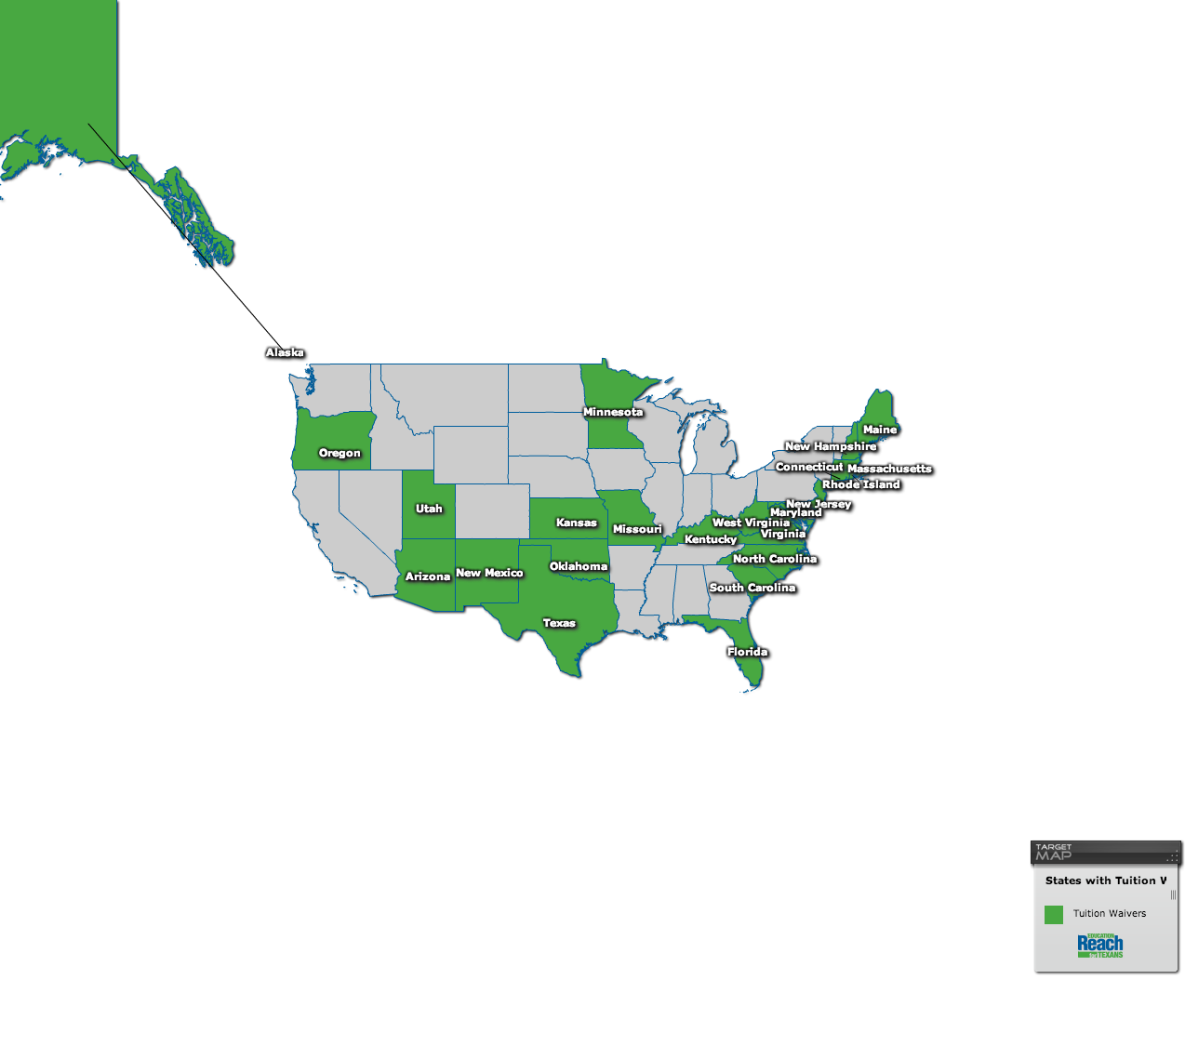

Figure 1: States with Foster Care Alumni Postsecondary Tuition Waivers

|  |  |
| --- | --- |
| * Alaska * Arizona * Connecticut * Florida * Kansas * Kentucky * Maine * Maryland * Massachusetts * Minnesota * Missouri * New Hampshire | * New Jersey * New Mexico (new) * North Carolina * Oklahoma * Oregon * Rhode Island * South Carolina * Texas * Utah (unimplemented) * Virginia * West Virginia |

## States with Postsecondary Institution Programs

Twenty states have self-identified as having college and university programs that support foster care alumni success. The numbers are likely greater and we can expect to see this list grow as the national movement continues to develop (sources: National Working Group on Students from Foster Care in Higher Education; 2013 National Convening on Foster Youth and Higher Education: Conference Proceedings-Los Angeles, CA; Fostering Success Michigan; individual campus Internet searches).

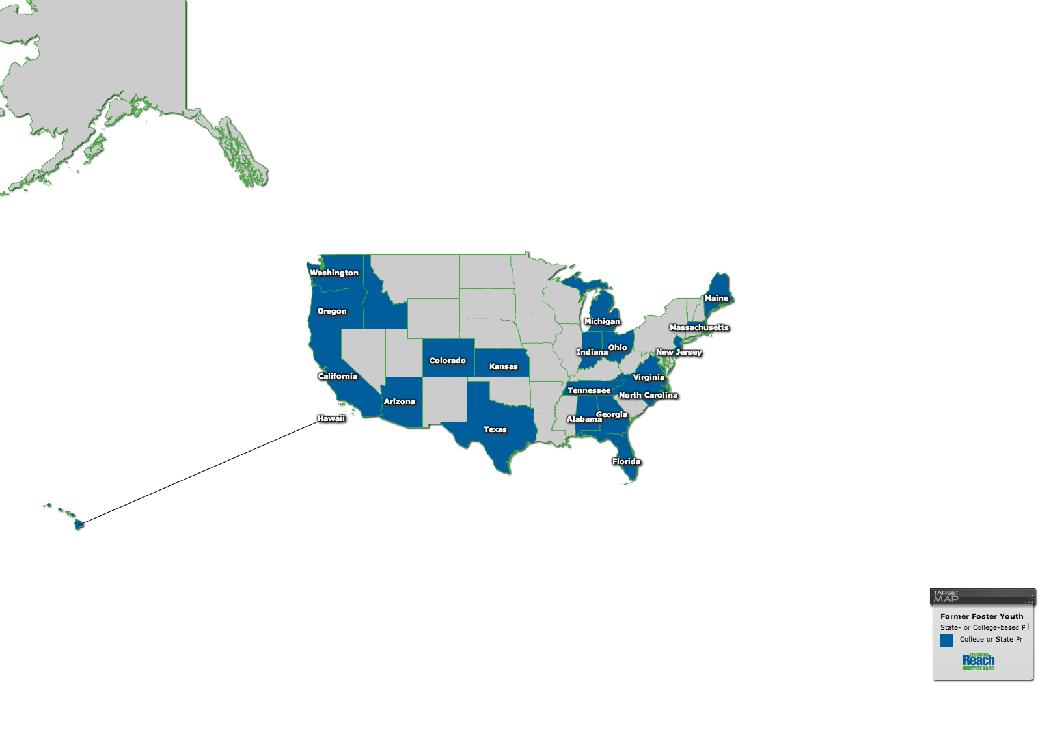

Figure 2: States with Postsecondary Institution Programs Supporting Foster Care Alumni

### Alabama

* University of Alabama: [Alabama REACH](http://reach.ua.edu/)

### Arizona

* Northern Arizona University - [Blavin Scholars Program](http://nau.edu/Student-Affairs/Blavin-Scholars-Program/) and a [story](http://www4.nau.edu/insidenau/bumps/2010/8_27_10/blavins.html) and a [video](http://youtu.be/lP9cZ1Abnf4)
* Arizona State University - [Nina Scholars Program](http://ninascholars.asu.edu/)
* Maricopa County Community Colleges - [Nina Scholars Program](https://my.maricopa.edu/preparing/special-programs), a district-wide program
* Chandler-Gilbert Community College
* Estrella Mountain Community College
* GateWay Community College
* Glendale Community College
* Mesa Community College
* Paradise Valley Community College
* Phoenix College
* Rio Saldo College
* Scottsdale Community College
* South Mountain Community College
* Maricopa Skill Center
* SouthWest Skill Center

### California

* California Polytechnic University, Pomona - [Renaissance Scholars](http://www.csupomona.edu/~ssep/renaissance-scholars/index.shtml)
* California State University, Dominguez Hills - [Student Support Services](http://www4.csudh.edu/sss/)
* California State University, East Bay - [Renaissance Scholars](http://www20.csueastbay.edu/academic/academic-support/sas/renaissance/index.html)
* California State University, Fullerton - [Guardian Scholars](http://www.fullerton.edu/guardianscholars/)
* California State University, Long Beach - [Foster Youth Resources](http://www.csulb.edu/divisions/students/eoc/links.htm#foster)
* California State University, Monterey Bay - [Foster Youth Advisor and Resource Website](http://admissions.csumb.edu/foster-youth) and [Compass Club](http://eosp.csumb.edu/csumb-compass-club)
* California State University, Northridge - [Resilient Scholars](http://www.csun.edu/csun-eop/eop-resilient-scholars)
* California State University, San Bernadino - [EOP Foster Youth Program](http://www.ugs.csusb.edu/eop/english/fosteryouth.html)
* California State University, San Marcos - [ACE Scholars Services](http://www.csusm.edu/ace/)
* California State University, Stanislaus - [Promise Scholars](https://www.csustan.edu/promise-scholars)
* Cerritos College - [Leaders Involved in Creating Change (LINC)](http://cms.cerritos.edu/financial-aid/linc.htm)
* Citrus College - [Foster Youth Success Initiative](http://www.citruscollege.edu/stdntsrv/finaid/fysi/Pages/default.aspx)
* City College of San Francisco - [Guardian Scholars](http://www.ccsf.edu/en/student-services/student-counseling/guardians-scholars-program.html)
* Humboldt State University - [ELITE Scholars Club](http://humboldt.edu/clubs/club_sites/elite_scholars_club)
* Pasadena City College - [Scholars Transitioning and Realizing Success (STARS)](http://www.pasadena.edu/studentservices/financialaid/starsprogram.cfm)
* Rio Hondo College -  [Foster Youth Success Initiative / Youth Empowerment Strategies for Success - Independent Living Program](http://www.riohondo.edu/socsci/fkc/yess-ilp_program.htm)
* San Diego State University - [Guardian Scholars](http://studentaffairs.sdsu.edu/EOP/Content/Guardian%20Scholars.html) and [Consensus Organizing Center, Foster Youth Initiative](http://consensus.sdsu.edu/fcc.html)
* San Francisco State University - [Guardian Scholars](http://www.sfsu.edu/~eop/gsp/index.html)
* San Jose State University - [Guardian Scholars](http://www.sjsu.edu/eop/programs/GS/index.html)
* Santa Ana College - [Youth Empowerment Strategies for Success (YESS)](https://www.sac.edu/StudentServices/EOPS/Yess/Pages/default.aspx)
* Santa Barbara City College - [Guardian Scholars](https://www.sbcc.edu/guardianscholars/)
* Santa Monica College - [Guardian Scholars](http://www.smc.edu/StudentServices/EOPS/Pages/Guardian-Scholars.aspx)
* Solano Community College -  [Foster Youth Success Initiative / Youth Empowerment Strategies for Success - Independent Living Program](http://www.solano.edu/counseling/fysi.php)
* University of California, Berkeley - [Cal Independent Scholars Network Program](http://trsp.berkeley.edu/cisn.shtml)
* University of California, Davis - [Guardian Scholars](http://success.ucdavis.edu/programs/gsp/)
* University of California, Los Angeles - [Guardian Scholars](http://www.guardianscholars.ucla.edu/) and the [Bruin Resource Center](http://www.brc.ucla.edu/) and a [video](http://vimeo.com/46937317)
* University of California, Riverside - [Guardian Scholars](http://guardianscholars.ucr.edu/)

### Colorado

* Colorado State University - [Fostering Success Program](http://oas.casa.colostate.edu/fostersuccess) and [a story](http://www.today.colostate.edu/story.aspx?id=4999)
* University of Colorado Boulder - [Guardian Scholars](http://www.colorado.edu/guardianscholars/home)

### Florida

* Florida Atlantic University
* Florida State University - [Unconquered Scholars](http://care.fsu.edu/Unconquered-Scholars)
* Florida International University - [Fostering Panther Pride Program](http://engagement.fiu.edu/growing-talent/fostering-panther-pride/index.html)
* Tallahassee Community College - [Fostering Achievement Fellowship Program](https://www.tcc.fl.edu/CommunityBusiness/SpecialPrograms/Fostering/Pages/default.aspx)
* Miami-Dade College - Campus Coach College
* Palm Beach State College - Foster College Achievement Program

### Georgia

* University of Georgia-Athens: [Embark UGA](https://www.fanning.uga.edu/what-we-do/youth-leadership-development/support-youth-higher-education)
* Savannah State University - STAR program

### Hawaii

* University of Hawaii – Honolulu (verification of program needed)

### Idaho

* Boise State University - [Impact Scholars Program](http://deanofstudents.boisestate.edu/impact-scholars/)

### Indiana

* Ball State University - [Guardian Scholars Program](http://cms.bsu.edu/Academics/CentersandInstitutes/SSRC/GuardianScholars.aspx)
* Indiana University-Purdue University Indianapolis - [Nina Scholars Program](http://nina.uc.iupui.edu/)
* Ivy Tech Community College - [Nina Scholars Program](http://www.ivytech.edu/indianapolis/nina-scholars.html)

### Maine

* University of Southern Maine

### Massachusetts

* Brandeis University

### Michigan

* University of Michigan - [Blavin Scholarship Benefits Students from Foster Care](http://studentlife.umich.edu/article/61)
* Wayne State University - [Transition to Independence Program](http://www.tipwaynestate.org/)
* Western Michigan University - [Seita Scholars Program](http://wmich.edu/fosteringsuccess/)
* Eastern Michigan University
* University of  Michigan-Flint - [Mpowering My Success](http://www.umflint.edu/finaid/mpowering-my-success)
* Aquinas College - [Fostering Success Scholarship](http://www.aquinas.edu/undergraduate/foster_scholarship.html)
* Baker College-Flint
* Ferris State University - [Ferris Youth Initiative](http://www.ferris.edu/HTMLS/administration/president/DiversityOffice/fofyi/homepage.htm)
* Saginaw Valley State University - [F.A.S.T. Youth in Transition Program](http://svsu.orgsync.com/show_profile/65080-f-a-s-t-youth-in-transition-program)
* Michigan State University - [Fostering Academics, Mentoring Excellence (FAME)](http://socialwork.msu.edu/outreach/foster_youth_alumni_svcs.php)

### New Jersey

* Rutgers University - [Summer Housing and Internship Program (SHIP)](http://socialwork.rutgers.edu/InstituteForFamilies/officeofchildwelfareinitiatives/TFY/Projects/SHIP.aspx)

### North Carolina

* J. C. Smith University - [Foster Care Initiative](http://www.jcsu.edu/about/foster-care-initiative) and [a story (see pp. 11-12)](http://mydigimag.rrd.com/publication/?i=96042)

### Ohio

* Miami University-Regional Locations - [Foster Care Liaisons](http://www.regionals.miamioh.edu//fostercare/)
* Ohio University - [Foster Care Task Force](http://www.ohio.edu/univcollege/fostercare/)
* Wright State University - [Independent Scholars Network (ISN)](http://www.wright.edu/independent-scholars/)

### Oregon

* Portland State University

### Tennessee

* Middle Tennessee State University - [Next Step Program](http://www.mtsu.edu/nextstep/)

### Texas

* Austin Community College - [Foster Care Alumni Program](http://www.austincc.edu/support-and-services/services-for-students/student-support-programs/foster-care-alumni-program)
* Dallas County Community College District - [Foster Care Initiative](http://www.dcccd.edu/emp/departments/ea/ts/fostercare/Pages/default.aspx)
* Texas State University-San Marcos - [Foster Care Alumni Creating Education Success (FACES)](http://www.vpsa.txstate.edu/programs-and-services/Foster-Care-Alumni.html)
* Texas Tech University - [Pioneers in Education: Generations Achieving Scholarship & Unprecedented Success (PEGASUS) Program](http://www.depts.ttu.edu/diversity/pegasus/)
* Texas Woman’s University - [Frontiers Program](http://www.twu.edu/twunews/press_releases/12-Frontiers-Program.asp)
* Sam Houston State University - [FORWARD Program](http://www.shsu.edu/dept/fye/forward/)
* University of Houston - [Urban Experience Program (UEP)](http://www.uh.edu/uep/)
* University of North Texas - [Persevere UNTil Success Happens (PUSH)](https://www.facebook.com/untpush)
* University of Texas-Austin - [Horns Helping Horns](http://deanofstudents.utexas.edu/nss/hornshelpinghorns.php)
* University of Texas at El Paso - [Foster Homeless Adopted Resources (FHAR)](http://www.utep.edu/FHAR)
* University of Texas at San Antonio - [ACCESS Center](https://utsa.edu/capri/access/index.html)
* West Texas A&M - [Buff Connections](http://www.wtamu.edu/student-life/buff-connections.aspx)

### Washington

* Seattle University - [Fostering Scholars](http://www.seattleu.edu/fosteringscholars/)
* University of Washington - [Champions Program](http://depts.washington.edu/omadcs/champions/)
* Washington State University - [Fostering Cougar Champions](http://universitycollege.wsu.edu/units/Passport/index.html)

### Virginia

* Community Colleges [Great Expectations State-wide Program](http://greatexpectations.vccs.edu/)
* Blue Ridge Community College
* Central Virginia Community College
* Danville Community College
* Germanna Community College
* J. Sergeant Reynolds Community College
* John Tyler Community College
* Lord Fairfax Community College
* Mountain Empire Community College
* New River Community College
* Northern Virginia Community College
* Patrick Henry Community College
* Piedmont Virginia Community College
* Southside Virginia Community College
* Southwest Virginia Community College
* Tidewater Community College
* Virginia Highlands Community College
* Wytheville Community College