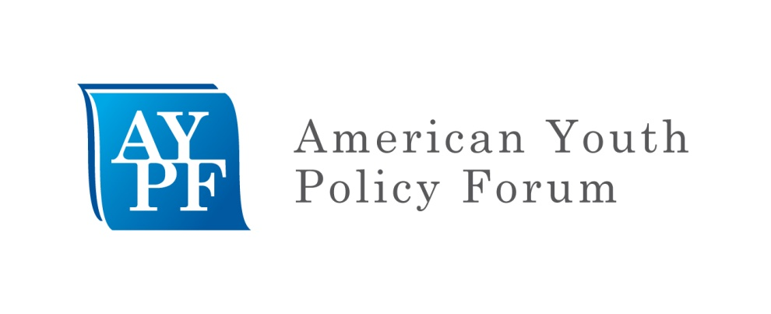
Competency-Based Pathways Maine Trip Overview
We are looking forward to our upcoming visit to Maine, a state that has been developing a proficiency-based education system for almost a decade. As you can see, we have a packed agenda, but we believe this trip will help begin an important conversation for the District on how to facilitate competency-based pathways to graduation. We know many of you have begun your own exploration of competency-based pathways and we can use this opportunity to gain deeper understanding of this work at both the state and district level and its possible opportunities for the District of Columbia to pursue competency-based pathways to graduation.
Your briefing binder contains a variety of background materials, both on competency-based education and the schools we will be visiting. Please bring this binder with you to Maine.
Below we have outlined some areas for consideration as we explore the possibilities of competency-based pathways to graduation for the District of Columbia students. These categories are not meant to be definitive, but rather spur your own thinking and provide you with leading research-based resources to assist you.
Why competency-based pathways to graduation for District of Columbia students?
Competency-based pathways to graduation allow for learning to be the constant, not time. Policymakers and practitioners are recognizing that an education system that uses time as a proxy for learning does not necessarily provide all students with the academic and other skills needed for college and career readiness (see below for proposed definition and resources). As the education system shifts towards more rigorous standards, different assessments, and improved technology, we have an opportunity to more accurately measure learning through the pursuit of competency-based systems that personalize pathways for all students. The current high school graduation requirements in the District only allow credit accrual based upon seat time. As the District of Columbia pursues a variety of strategies to improve student outcomes that align with the desire to ensure students have all the knowledge, skills, abilities, and disposition to be successful, we must consider competency-based pathways to graduation.
What is competency-based education?
Competency-based education typically is defined within the context of the locality; we have provided a working definition to help spur on your own thinking as we work towards defining the opportunities to develop competency-based pathways within the District. We have included some footnotes to highlight concepts for further consideration and identify current approaches (many source documents can be found in your binder or links are provided in the annotated resource list).
What policy considerations are critical to a competency-based system?
It is important to understand that competency-based education can be facilitated by a supportive policy environment at the state and district level. We have listed a number of policy issues for consideration. Please do not assume this a list of everything that must be done, rather these are issues for consideration. We have defined some specific concerns under many of these issues, again these are not comprehensive, but rather a starting point for discussion and consideration. There is not a process guide to build a competency-based system, yet there a number of policy issues for consideration at the school, district, and state level:
- Common and comprehensive articulation of what it means for a student to be college and career ready;
- High school graduation requirements facilitate district-created definitions of the set of competencies all students should master;
  - Removal of time as only requirement for credit accrual (e.g. Carnegie unit)
  - Ability for students to create personalized pathways based upon their interest (e.g. integration of career and technical education, accelerated learning opportunities, and expanded learning opportunities)
- Standards/Curriculum/Assessment;
  - Clearly articulated standards that allow for district development of competencies
  - Flexibility within curriculum to allow for personalization
  - Flexibility of assessment timetables to allow students to progress when ready
- Data systems that measure students mastery of competencies;
  - Schools/districts capacity to document and share student progress
  - State ability to aggregate school district data
- Teacher and school leader preparation, professional development, and evaluation;
- Communities of practice to build collective capacity;
  - Role of technical assistance providers
  - Coordination and collaboration among districts
- Role of technology in the classroom;
  - Online/Blended learning
  - Online assessment
- Structures of schools that support a competency-based system;
  - Master schedule
  - Ability of students to progress at appropriate pace
- Community engagement.

Proposed definition for District of Columbia and college and career readiness resources
There is generally consensus that being prepared to succeed upon completion of high school means that a student must master more than academic content. While there is no consensus definition of what it means to be “college and career ready,” there has been much discussion of the types of knowledge, skills, abilities, and dispositions that students need to be considered ready and subsequently successful. Based upon conversations with many of you, we would like to propose the following working definition to serve as a guide:
Postsecondary Readiness for Careers and Lifelong Learning
- The student has knowledge of the choices available and the steps to meet their own goals for college and career. [System Navigation Knowledge and Skills]
- The student is able to take credit bearing coursework towards a postsecondary degree and/or career certification without the need for remediation. [Content and Career Skill Mastery]
- The student has developed the skills necessary to succeed in a "self-driven" environment. [Non-academic skills: socio-emotional, cultural literacy/proficiency, global awareness, self and group advocacy]
This working definition draws from the following documents included in your binder:
- Defining College and Career Readiness Resource Guide (National High School Center)
- Success at Every Step: How 23 Programs Support Youth on the Path to College and Beyond (AYPF; See binder materials for logic model)
- College and Career Development Organizer (National High School Center; See binder materials for full copy)
Proposed Definition of Competency-Based Learning
Competency-based learning (CBL) is a student-centered approach to preparing students for college and career that is organized around competencies derived from societal and student needs. It de-emphasizes time-based advancement and promises greater accountability and personalized learning. The key components of a competency-based approach are as follows:
- Students advance upon mastery.
- Competencies include explicit, measurable, transferable learning objectives that empower students.
- Assessment is meaningful and a positive learning experience for students.
- Students receive timely, differentiated support based on their individual learning needs.
Learning outcomes emphasize competencies that include application and creation of knowledge, along with the development of important skills and dispositions.

Competency-based education has gone by many names—proficiency-based, mastery-based, performance-based, etc. While all systems have variations, the basic concepts are fairly universal and will be described below.
How do we define a student-centered approach? See Jobs for the Future Students at the Center Project; Hewlett Foundation Deeper Learning
What is a competency? Many definitions. See Competency Works, The Art and Science of Designing Competencies, 2012
What is advancing upon mastery? - Students advance based on mastery, not age; - earn credits based on demonstration of mastery - work at levels that are appropriately challenging; - are evaluated on performance; complete courses at different speeds (Competency Works, When Success is the Only Option, 2010)
How are competencies designed? - relationship between student and teacher focuses on facilitation and formative assessment; - learning becomes modular so when a student masters a learning objective, they can gain value for their work even if they move schools; learning expands beyond the classroom through digital learning, OST programs, youth programs, or independently. (Competency Works, When Success is the Only Option, 2010)
What assessments can measure the knowledge, skills, and dispositions we want to achieve? What does a meaningful assessment and what does it look like? How can we create a positive learning experience through assessment? - Schools focus on formative assessment to drive instruction; - schools need information management systems so teachers and administrators can see where students are struggling; - teachers collaborate to understand what is adequate demonstration of proficiency; - teachers assess in multiple contexts and multiple ways. - Students must demonstrated proficiency multiple times - Examples include formative assessments, digital learning tools, performance-based assessments, presentations, and peer to peer instruction; summative assessments are adaptive and timely. Students should be assessed on learning objectives they demonstrated proficiency in. (Competency Works, When Success is the Only Option, 2010)
How do we define the application and creation of knowledge? How do we incorporate them into learning outcomes? There are very different approaches to this. See (Competency Works, When Success is the Only Option, 2010, p. 18); Envision Graduate profile; Asia Society Graduate Portfolio Performance Rubric; NH Waiver request, p. 15

